Name: Vemula Rajeev Kalyan
Hall Ticket: 2403A51324
Batch:13

Task Descriptioun:1
• Zero-shot: Prompt AI
write a function that checks whether a given year is a leap year.
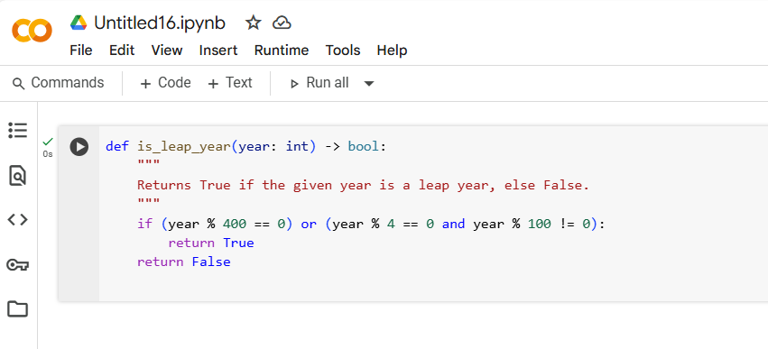
Observation:
In the zero-shot prompt, the AI generated a correct function using only the rule-based logic of leap years without needing any examples. This shows that zero-shot prompting works well for well-defined logical tasks, as the AI directly applies the known conditions for leap years.

Task Description:2
• One-shot: Give one input-output example to guide AI in writing a function that
converts centimeters to inches
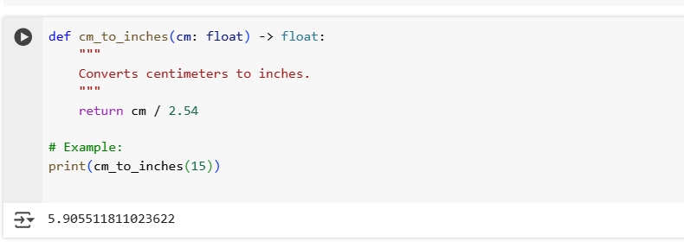
Observation:
In the one-shot prompt, providing a single input-output example (10 cm → 3.937 inches) helps the AI understand the conversion formula. This makes the generated function more precise and aligned with the expected logic compared to zero-shot prompting.

Task Description:3
• *"Write a Python function that formats full names as 'Last, First'.
Examples:
- 'John Smith' → 'Smith, John'
- 'Alice Johnson' → 'Johnson, Alice'
- 'Michael Jordan' → 'Jordan, Michael'"*
”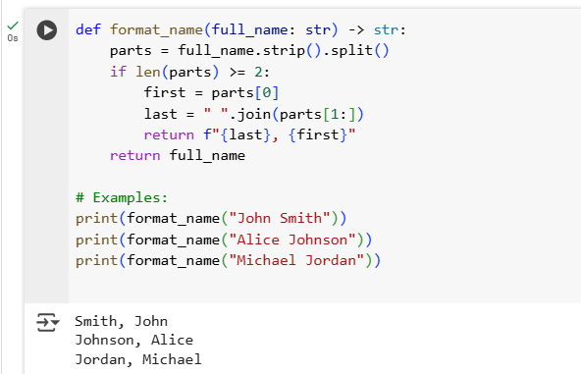
Observation
In the few-shot prompt, multiple examples clearly guide the AI about the exact input-output relationship. This reduces ambiguity and helps it generalize better, especially if names have more than two parts.

Task Description:4
• Compare zero-shot and few-shot prompts for writing a function that counts the
number of vowels in a string
Zero-shot Prompt:
"Write a Python function that counts the number of vowels in a string."
CODE:

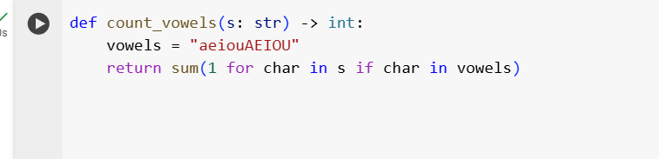

Observation:
The AI generated a correct function directly. It handled uppercase and lowercase vowels even without examp
Few-shot Prompt:
*"Write a Python function that counts the number of vowels in a string.
Examples:
- Input: 'hello' → Output: 2
- Input: 'ChatGPT' → Output: 2
- Input: 'Python' → Output: 1"*
CODE:
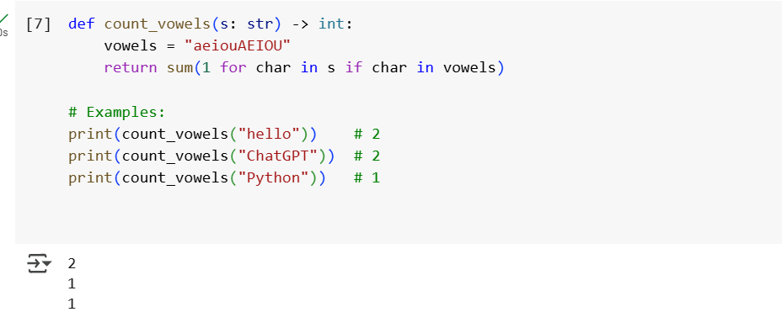
Observation:
Few-shot reinforced the expected outputs, removing ambiguity (like whether uppercase vowels count). It gives the AI more confidence in the exact transformation.

Task Description:5
• *"Write a Python function that reads a .txt file and returns the number of lines.
Examples:
- If the file contains:
Hello
World
→ Output: 2
- If the file contains:
Python
AI
Rocks
→ Output: 3"*

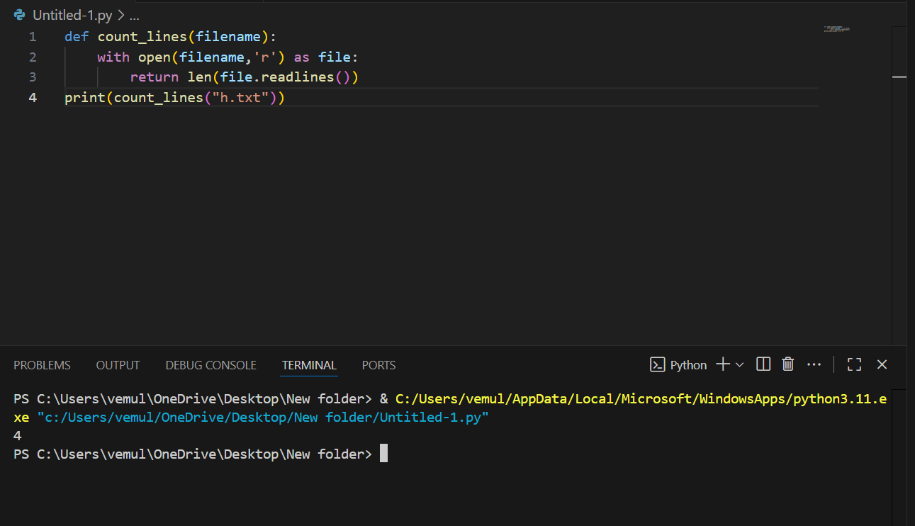
Observation
Few-shot prompting clarified the task by providing examples of input file contents and expected outputs. This guided the AI to count lines only (not words or characters) and ensured it returned the correct result even for different cases.

